Critique #2:

EDUC 8120

George Washington University

Were Vincent

**The dataset** you (and your fictitious peers) will be working with is located here ([Merged Round 8 data (34 countries) (2022) – Afrobarometer](https://www.afrobarometer.org/survey-resource/merged-round-8-data-34-countries-2022/) )

After reading through each of the three scenarios below, **for each scenario** you will do the following:

1) Examine the Afrobarometer dataset and determine if you believe (or do not believe) the suggested ANOVA investigation can be performed to inform the study

2) If you agree that the suggested ANOVA investigation can be performed, write a 2-3 paragraph brief persuasive essay explaining why the method is appropriate. Using a table, list ONE SET of possible variables, the variable levels of measurement, factor levels, independent/dependent, and descriptions that could be used to inform the study using the suggested ANOVA technique. Run the analysis including **descriptive statistics, assumption checking, minimum sample size, group comparison, post hoc, effect size, and power** (use subheading titles) generated evidences and interpretation of results.

3) If you disagree that the suggested ANOVA investigation can be performed, write a 2-3 paragraph brief persuasive essay explaining why the method is not appropriate. Next, suggest an ANOVA investigation method which would be appropriate. Using a table, list ONE SET of possible variables, the variable levels of measurement, factor levels, independent/dependent, and descriptions that could be used to inform the study using your alternate suggested ANOVA technique. Run the analysis including **descriptive statistics, assumption checking, minimum sample size, group comparison, post hoc, effect size, and power** (use subheading titles) generated evidences and interpretation of results.

**Scenarios**

A. James is a graduate student interested learning more about African society. More specifically, he is interesting in investigating if political views differ among Africans in different age groups. He decides to use the Afrobarometer dataset as a secondary source for his investigation. He believes that he can perform a one-way ANOVA analysis to help inform his study.

**Table 1**

*Variable Information*

|  |  |  |
| --- | --- | --- |
| Variable Type | Variable Labels | Levels of Measurement |
| Dependent Variable | Discuss Politics | Ordinal Variable |
| Independent Variable | Age_V5 | Scale Variable |

**Table 2**

*Descriptive Statistics*

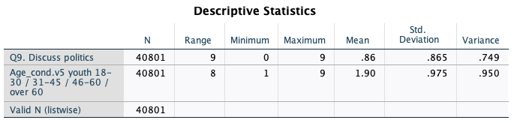

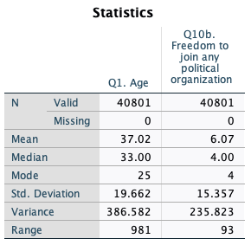

**Table 3**

*Assumption Checking*

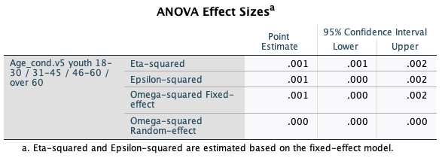

Leven's Test

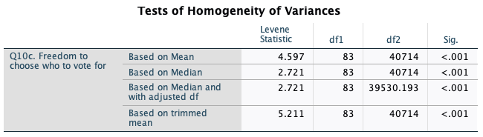

To test for normality I used the Histogram and Shaπro−Wilk test to check if the data distribution is normal. If you plan to do group comparisons, the variances of the groups should be equal. Use to check this To test the homogeneity of variances I used the Leven’s test. I ensured that the data points are independent of each other.

**Minimum Sample Size**

Determine based on desired power (typically 0.8) and significance level (typically 0.05).

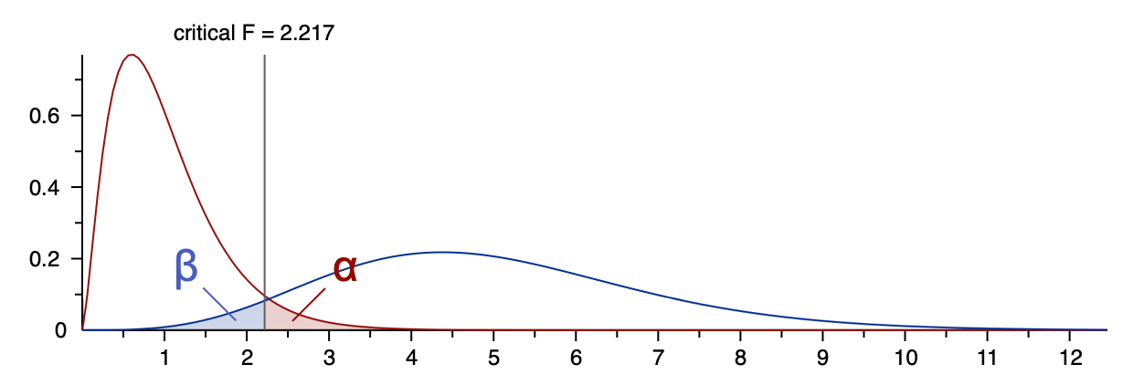

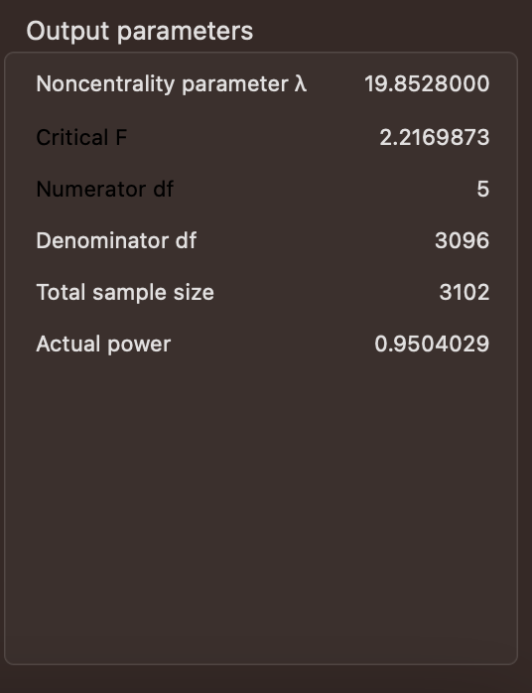

**Sample Size is 3102.**

We run the Tukey test because the assumptions have been met, and there is a significant mean difference (reject the null) to see which variable means within test are significantly different

**Group Comparison/Post Hoc**

Since the ANOVA is significant using the Tukey multiple comparison test reveals there is a sig value of 0.792, This means there is a Significant difference between the categories in the dependent variable. The groups that are specifically different are ages 18-30 in comparison to ages over 60. See Table below.

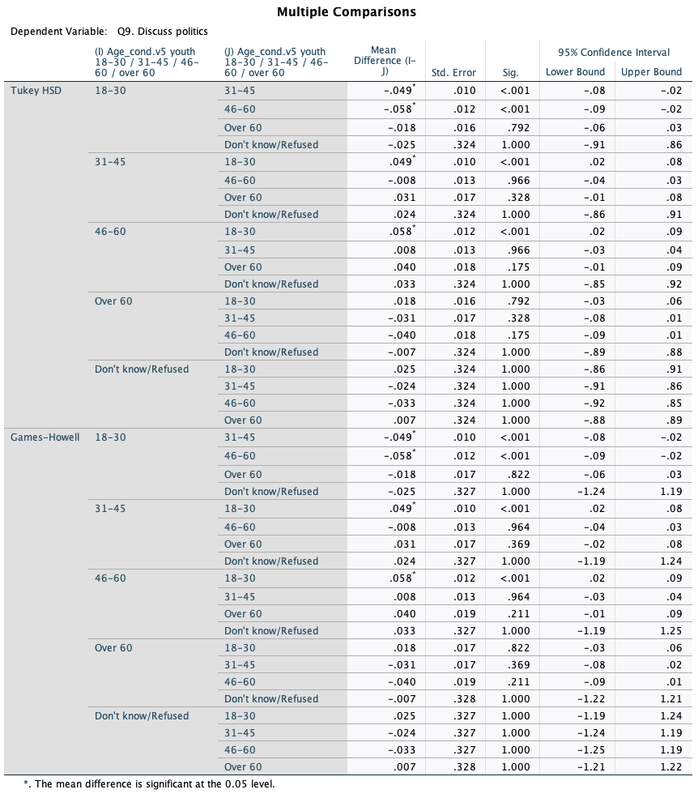

**Effect Size - 0. 08**

Calculate appropriate effect size

**Power - 0**

Ensure you have adequate power (preferably above 0.8) based on effect size, sample size, and alpha level

1. Based on your effect size, sample size, and alpha level (usually 0.05), calculate the statistical power. This indicates the likelihood that if there is a true effect, you will detect it. Aim for power values of 0.8 or higher.

.

**Interpretation**

James' plan to use a one-way ANOVA analysis is suitable for comparing means among different age groups. However, he should ensure that the assumptions of ANOVA are met and consider additional analyses or post-hoc tests if necessary, depending on the nature of the dependent variable's measurement. The groups that are significantly different are the groups that are above the age of 30. Political views (A-political and political vary in ages)

**B.** Joyce is a graduate student member of an international education services support team. Ever since the height of the COVID-19 lockdown crisis starting in 2020, they have been assigned to offer equity support services to families with children enrolled in African schools. Joyce and her team suspect that differences in poverty levels are detectable given implemented COVID-19 related considerations and race. To help inform their study, Joyce’s team believes will use the Afrobarometer dataset and believe that a within-subject ANOVA can help inform the study.

**Descriptive Statistics:**

* Independent Variable: Race (Nominal) Q102 & COVID-19
* Dependent Variable: Poverty Levels - lived Poverty Index (Scale) - Line 403

**Table 1**

*Variable Information*

|  |  |  |
| --- | --- | --- |
| Variable Type | Variable Labels | Levels of Measurement |
| Dependent Variable | Poverty Index | Scale Variable |
| Independent Variable | Race | Nominal Variable |

**Table 2**

*Descriptives Table*

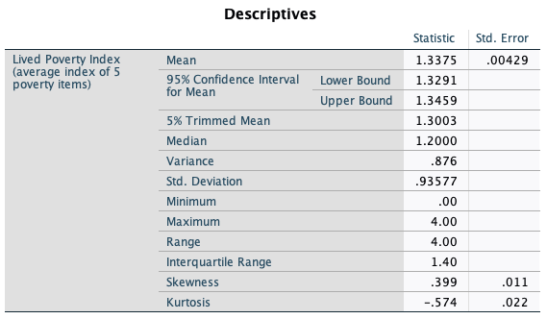

**Research Question:** Is poverty level associated with race?

Null: There is no difference in mean pverty scores between race groups

Alternative: There is a significan mean difference between the two variables.

**Table 2**

*Tests of Normality*

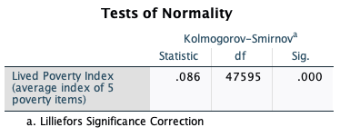

**Figure 1**

*Histogram*

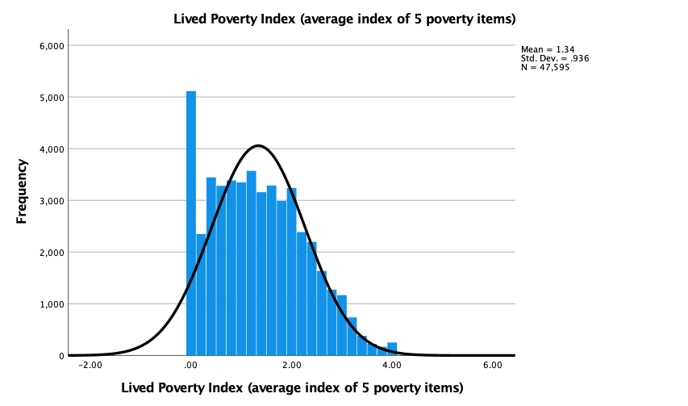

**What is the Homogeneity of Variances:** If there are repeated measures (within-subjects), you need to check for assumption. Mauchly's test can be used to assess sphericity assumption.

**What is the Minimum Sample Size:**

**What is the sample size**

Is there a need for Post Hoc?

**What is the Effect size? Use G*Power**

**What is the Power Used? Why?**

**Interpret:** write a 2-3 paragraph brief persuasive essay explaining why the method is appropriate (If you agree that the suggested ANOVA investigation can be performed)

C. Kai is a political science graduate student interested in democracy and African governments. Recently he has wondered about the existence of relationships between how views related to the characteristics of presidential candidates and democracy considerations. He recently discovered the Afrobarometer dataset. In his graduate statistics course he learned about the factorial ANOVA analysis technique and believes he can use it to inform his study.

Variable:

Presidential Candidates

Democracy Consideration